Name: Cullen McCain
Age: 14
Town: Topeka, Kansas
School: Topeka Public School
Problem: Brought a weapon to school.

Name: Caroline Baker
Age: 16
Town: Miami, Florida
School: Benjamin Franklin Public High School
Problem: Wore a bikini to school.

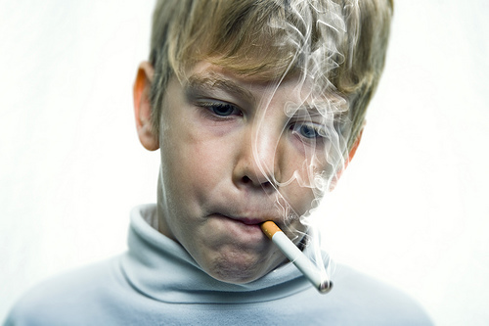
Name: Jonathan Smith
Age: 17
Town: St. Paul, Minnesota
School: Thomas Jefferson Academy Preparatory School
Problem: Caught smoking in school.

Name: Michelle Thompson
Age: 15
Town: Houston, Texas
School: Big Cowboy Public High School
Problem: Missed 13 days of school.
Name: Peter Long
Age: 13
Town: Juneau, Alaska
School: James Madison Private Middle School
Problem: Bullied another student on the playground

Name: Tina Potter
Age: 18
Town: Boston, Massachusetts
School: Boston Central Public High School
Problem: Missed school because of a college visit

